**Poinsettia Unrooted Cuttings Handling, Propagation**

Roger Kehoe, Horticulturist

Here are some suggestions for best results in propagating poinsettias.

* Store URC at 55° F, under high humidity, until planting. Colder temperature might damage them. Warmer temperatures increase mortality and cutting weakness.
* Plant as soon as possible. Waiting two or three days to plant is too long, freshness is key.
* Light level mid day adjusted to 1200-1500 FC.
* Plain water in mist. Fertilizer may burn the foliage or tips of the stems.

Some growers point out that they do fine with different practices than recommended. It is possible, with any crop, to do things differently. Recommendations made are for a broad range of conditions and every greenhouse is unique. If you are in the northern tier of states and have cooler temperatures and do not grow much other than red poinsettias, then higher light levels in propagation may work. There are some growers with very pure, low EC (electrical conductivity is related to salts dissolved in the water, a lower number is better) water and low alkalinity water that mist heavily under higher light levels like 2500 FC. For them, it works ok. But if your water quality is not that great and you grow a lot of novelty varieties, then you can run into problems. If you have a system that works, don’t change it. But be certain to record all the details of what you are doing so that if something goes wrong later on, you have a solid base line of data to compare to.

**Media considerations for poinsettia propagation**

Poinsettias root well in many different media, from artificial foams to regular potting mixes- in both liner production and direct stick programs. The key is to have the pH adjusted correctly, and enough oxygen in the media for good callus to form, and subsequent rooting out to occur. Most commonly seen with cases of poor callus formation in saturated media which correlates to low oxygen levels. Causes of soggy saturation are typically poor media structure, or too much water applied, or both. Again, with light levels as prescribed and diligent mist management, saturated media should not be a problem.

But you can’t dry prop poinsettias in the summer heat, so it is necessary to use a well drained media. Peat moss can have too many fines in it, be sure to use a high quality peat that does not. Media porosity around the base of the cutting is critical to success. Poinsettias are particularly sensitive to this. This is what happens: they look the same after 10 days in propagation as they did when they were stuck. No healthy white callus formation, no roots, not even much of any swelling of the base of the stem. That is the effect of low media oxygen on poinsettias. They do not necessarily rot and die, although it is eventually possible; but disease is not the primary problem here. This is all assuming your media is warm, 68F to 72F. Cold media can cause this delay of growth also but *not usually in July*! Later propagations in August may suffer from the cool nights if heat is not applied.

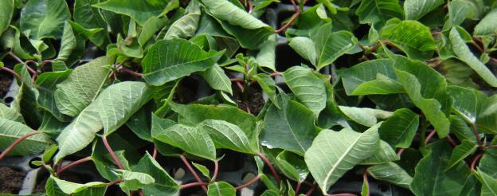Too dry in propagation, leaves curl. Freshly stuck is one thing, but these were here for more than a day and notice that there is no water standing on these leaves, they are dry.

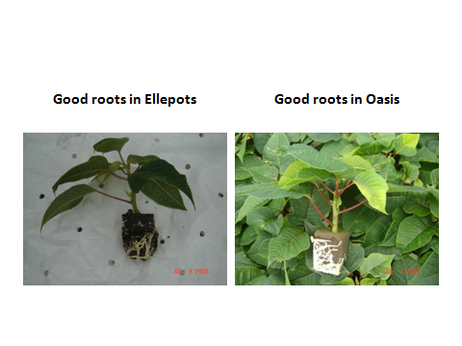

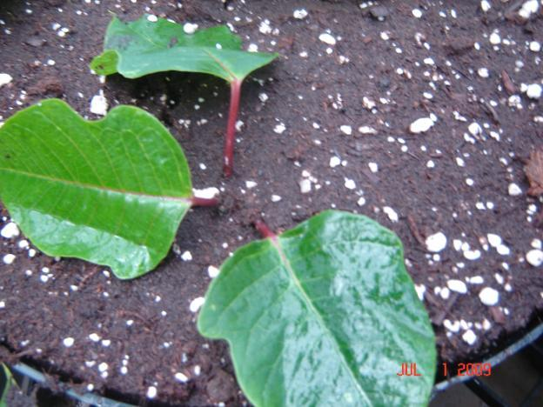

Don’t bury the tips! This cutting will not survive.

Direct stick programs usually have adequate oxygen in the media, and are not usually water logged. This is because they have greater soil depth and drain better at the top of the media. It is harder to water log the top of a higher and longer soil column. Gravity maintains drainage in the upper soil profile. Shallow liner cells do not have this natural drainage capability, so soil structure and porosity are more critical to success.

If you are propagating on wire or open mesh benches, consider placing poly under the cuttings, especially when doing liner propagation. This reduces excessive air movement in the summer, and very importantly *reduces mist needs*. All this is important because a superior micro climate is developed where less mist is applied yet humidity is higher near the cuttings- a desirable condition. Note the drain holes in the poly liner. We do not want puddles of standing water. This technique works in the summer because it is warm, the greenhouses are well ventilated, and poinsettias respond well to high humidity. In winter geranium propagation, this could be a disaster due to cool wet disease promoting conditions.

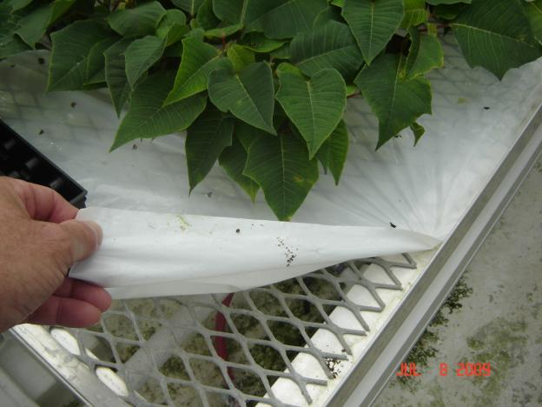

Many growers ask about using a wetting agent (surfactant) such as Aqua Gro or Capsil. These may be useful. Research has shown that with surfactant applications tissue weight is increased rapidly as water droplets are more readily absorbed into the leaf. That’s a good thing. When used, surfactants should be applied as quickly after sticking as possible. Be careful not to over apply, use a rate within label instructions. High rates can promote leaf damage, low rates don’t do any good. The best way to dose this correctly: apply at the lowest rate possible where the water droplets disappear and the water flattens out on the leaf without beading. Also, be certain to take into account surfactants present in applications of plant growth regulators (PGR) and pesticides. The affects of application can be additive, and after spraying several times there can be an excess accumulation. For example, B-9 is a widely used and very good PGR for poinsettia propagation, and it contains a surfactant. And there are other chemicals commonly applied, and they are good to use when needed, just be careful to consider these other chemical’s surfactants when applying additional surfactants. Always follow label instructions carefully. Poinsettias do not have a thick cuticle and it can be damaged, leaving the leaf tissue more susceptible to desiccation and damage from other stresses like pesticide sprays and sun scald.

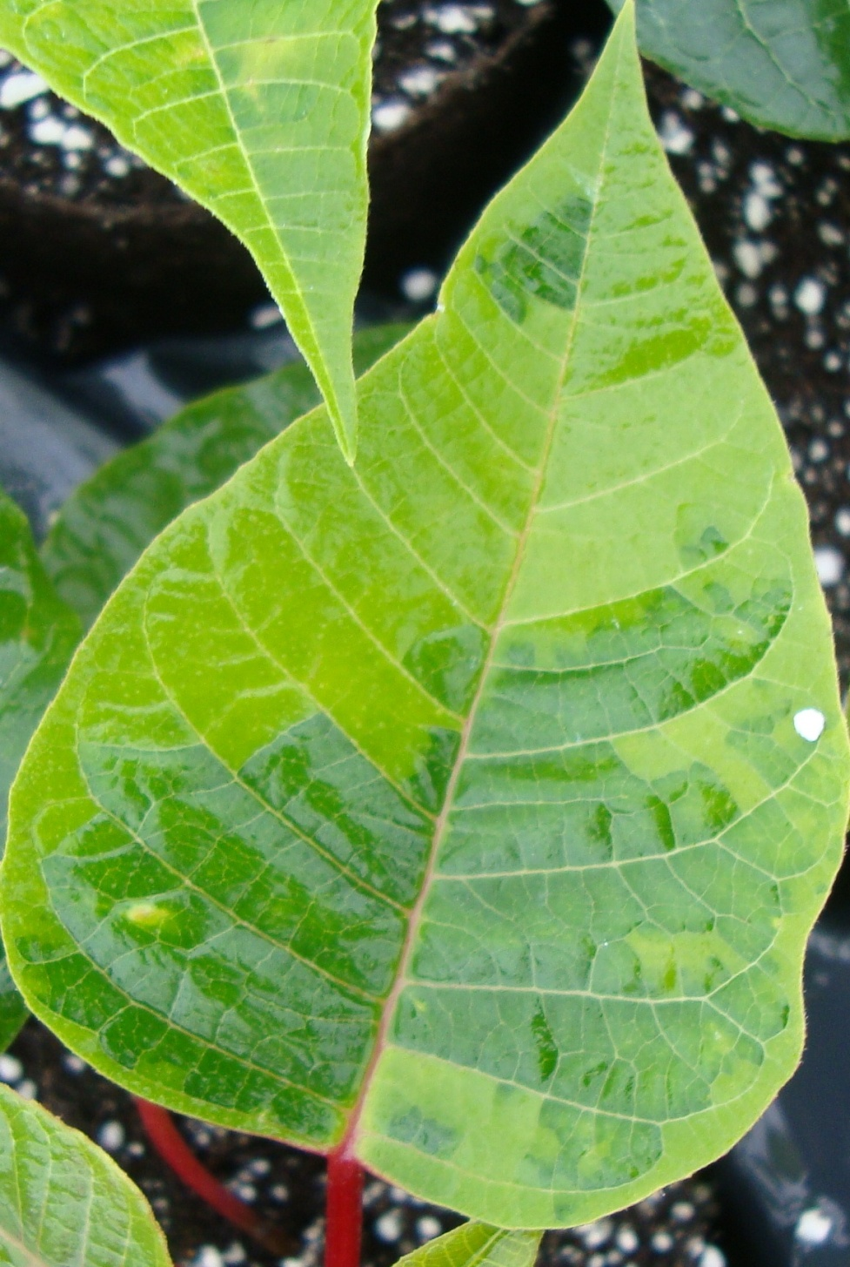

Cuticle breakdown from surfactants. This leaves the tissue open to sun burn and desiccation, as well as chemical burn.